Visualization of Formula One Career Results
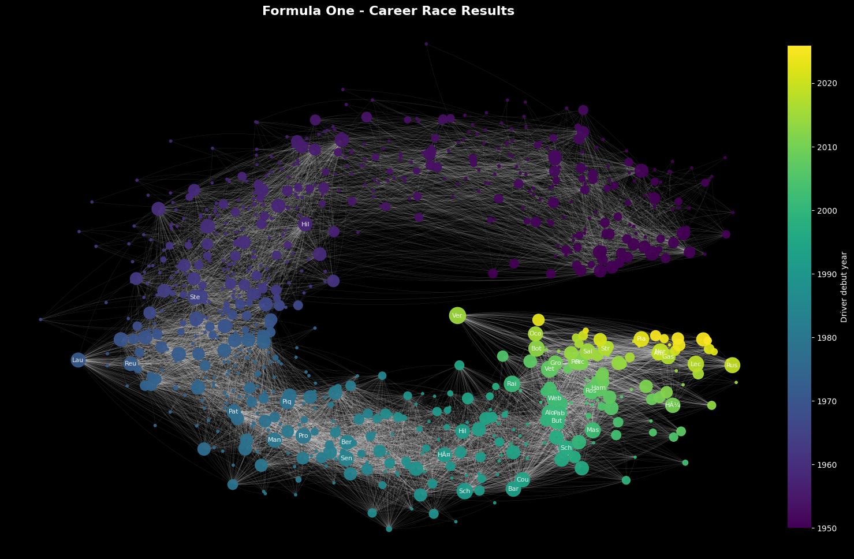
Fig. 1: Formula One Career Results
Introduction
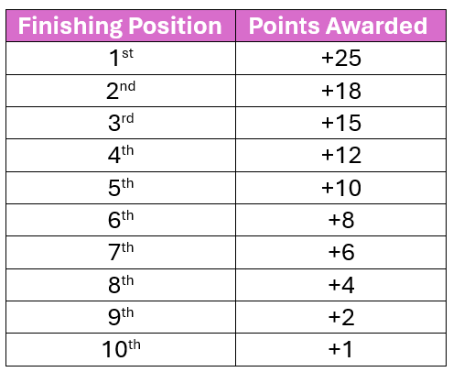
Formula One is considered the highest class of international in open-wheel single-seat racing. Having just celebrated the 75th anniversary of the sport, the sport has had consistent formatting of 20 drivers and 10 teams (2 drivers per team) with a varying number of races per season. However, the 2026 season introduced an 11th team, making it a total of 22 drivers per season. Race results are based on finishing position in the final lap of a race, which can vary depending on the circuit, as circuit laps vary in distance, total lap count is adjusted to maintain a consistent of ~305 km per race. Based on the finishing position of each race, drivers are awarded points.
Dataset
The Formula One Race Data[1] used for this project was sourced through Kaggle. The dataset contains 14 different tables with data ranging from seasons beginning in 1950 and through 2025. This data does not contain the current (2026) season and therefore does not reflect the addition of an 11th team or the additional 2 drivers. With the use of Microsoft Access, I combined 5 of the available tables (Results, Drivers, Race Status, Races, Lap Times) to create a consolidated table[2] of 27,304 records. Instances of a race status outside of “Finished” were not removed because a status of retired or DNF still contributes to race result and position. The inspiration for the structure of the graph comes from the YouTube video “ I Made a Network of Every Home Run in MLB History” by adumb (link)
Visualization and Analysis
In figure 1, Nodes represent driver initial debut, with earliest (1950) = purple, latest (2025) = yellow.
- The edges depict race results of each driver; the connection is linked to the driver that finished in the position directly behind them (ex. Driver 1 finished 1st -> Driver 2 finished 2nd).
- Nodes are clustered based on common links. If they finish next to each other often, they will be closer together.
- Node size is determined by a driver’s total career points; larger nodes are more successful.
- There is a distinct gap between purple nodes and yellow nodes due to the average career length of a Driver consisting of 3-5 years, making overlap impossible
Figure 2 shows the top 40 drivers with the longest careers
- Calculated based on debut season and final season
- As we the year increase, career length has increased
- Drivers that debuted in 2000s have had a higher average of career length
Figure 3 shows each of the top 40 drivers and their strongest connection.
- Strength is determined by edge weight (number of connections)
- Earlier nodes (purple) we see much longer connections, indicating longer career length
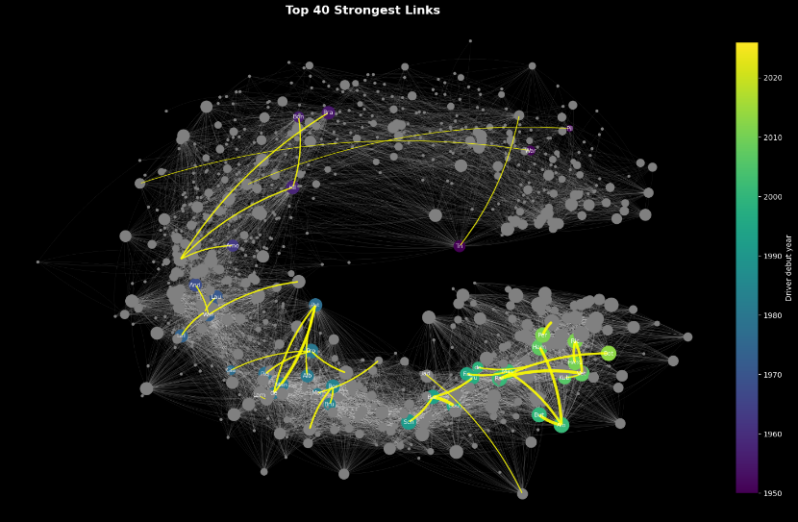
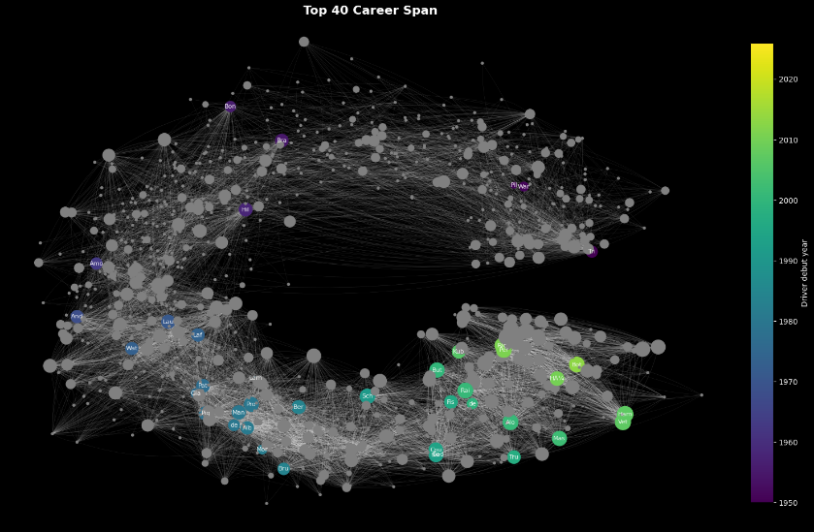
- Consistent performance increases as the year goes up; links are thicker
Fig. 2: Top 40 Drivers with longest career span Fig. 3: Top 40 Drivers strongest links
In Fig 4. The top 40 drivers’ maximum points earned in one season vs. career span
- Analyze if there is corresponding relationship between career length and peak performance.
- There is an average of about 12-year career spans for the top 40 drivers
- most do not reach season performance peaks of above 100 points.
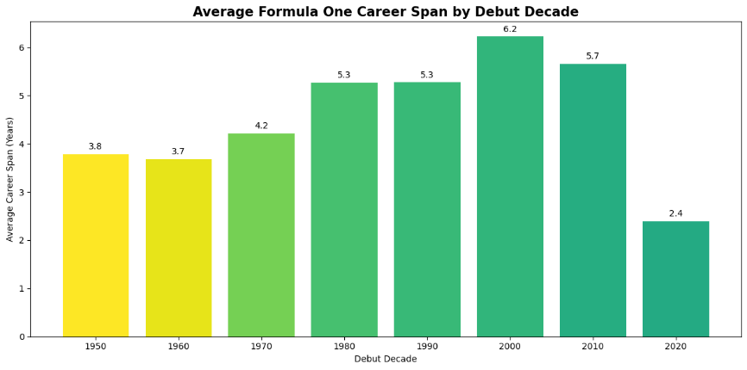
- Higher max season points are drivers that have debuted within the last ~20 years

Fig 3 average career span with respect to debut decade

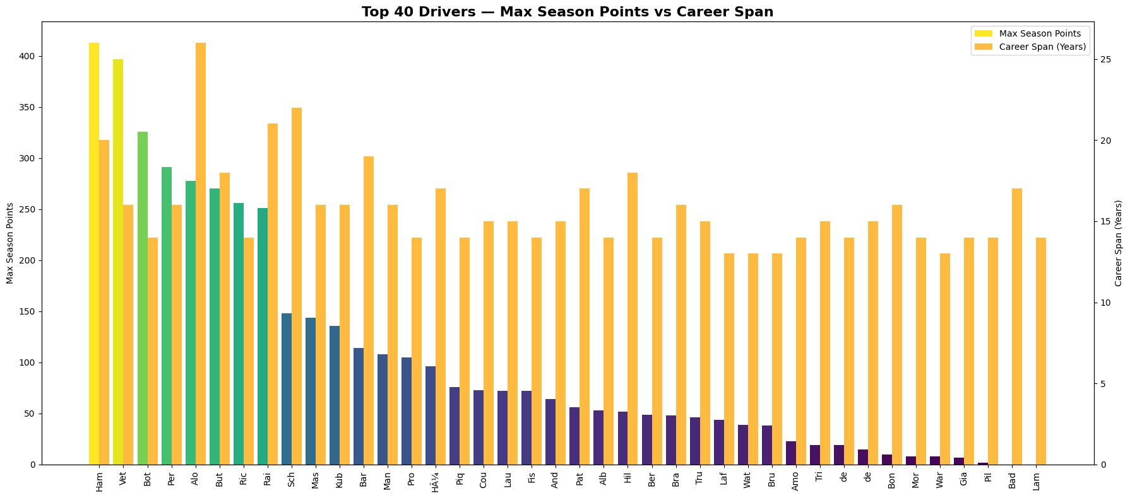

Fig. 4: Lifetime Points of Top 40 Longest Career Drivers

Conclusion
As we approach the year 2025, we see an increase in node size indication that general performance of drivers is increasing. This is likely an indication of increased talent but also an increase in machinery capabilities. Additionally, strongest links decrease in length over time, this is an indicator of consistent finishing, showing drivers have more direct rivals, despite drivers with earlier debut having a higher average of career length. Career length is not an indicator of peak performance, as we observed the top 40 career length drivers and found that most had not reach a peak of100 points in one season. This is a sport that is heavily dependent on technology so it makes sense that there will be an increase in performance as years increase following technological advancements in sport.
Importance
There is a lot of debate within the sport about exclusivity, which leads to shorter career spans. Many fans get upset when their favorite driver gets replaced and feel it is unfair. But to keep the reputation of “the pinacol of motorsport” it is important to prioritize performance over “fairness” and this helps to understand that historically a driver can have a successful career both by maximizing points per season and by being a consistent mid-tier driver.
References
[1] https://www.kaggle.com/datasets/jtrotman/formula-1-race-data?select=circuits.csv
[2] Consolidated data "Results_4.xlxs"
[3] https://youtu.be/LtJxJqAqt0Q?si=Zws-8BVfBcJ-Nqno
[4] https://github.com/Hansen411/Final-Project/tree/main

